







UID /dev/

ReadySetResource.com

Contents

13.1 - Dashboard 3

13.2 - Error Analytics 4

13.3 - Data Transfer Rate Analytcs 5

13.4 - Traffic Analytics 6

13.5 - UID /dev/ Work Log 7

# 13.1 - Dashboard

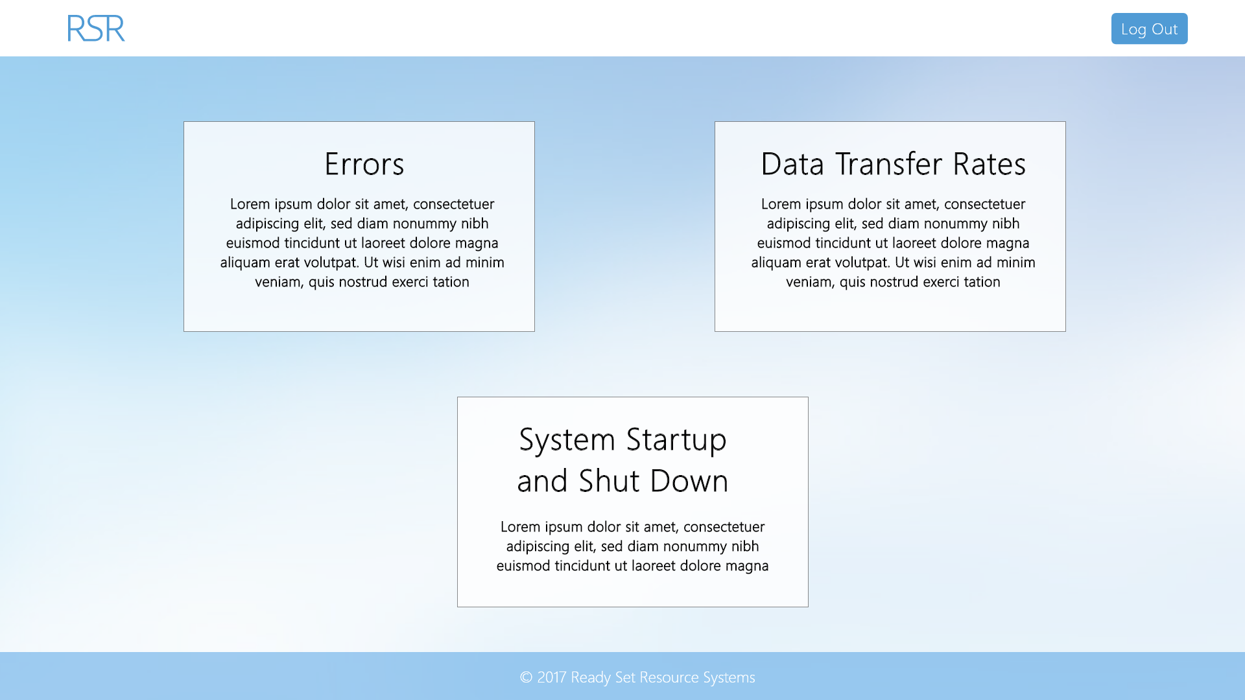

Input Permissible: None

Error Messages: None

# 13.2 - Error Analytics

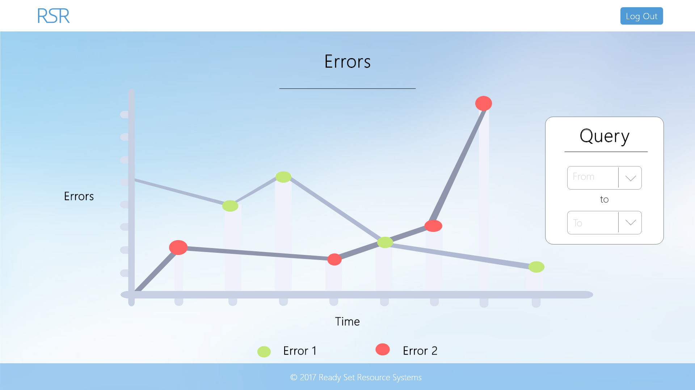

Input Permissible: - Date From

- Date To

Error Messages: - ‘Cannot select a date before start date’

# 13.3 - Data Transfer Rate Analytics

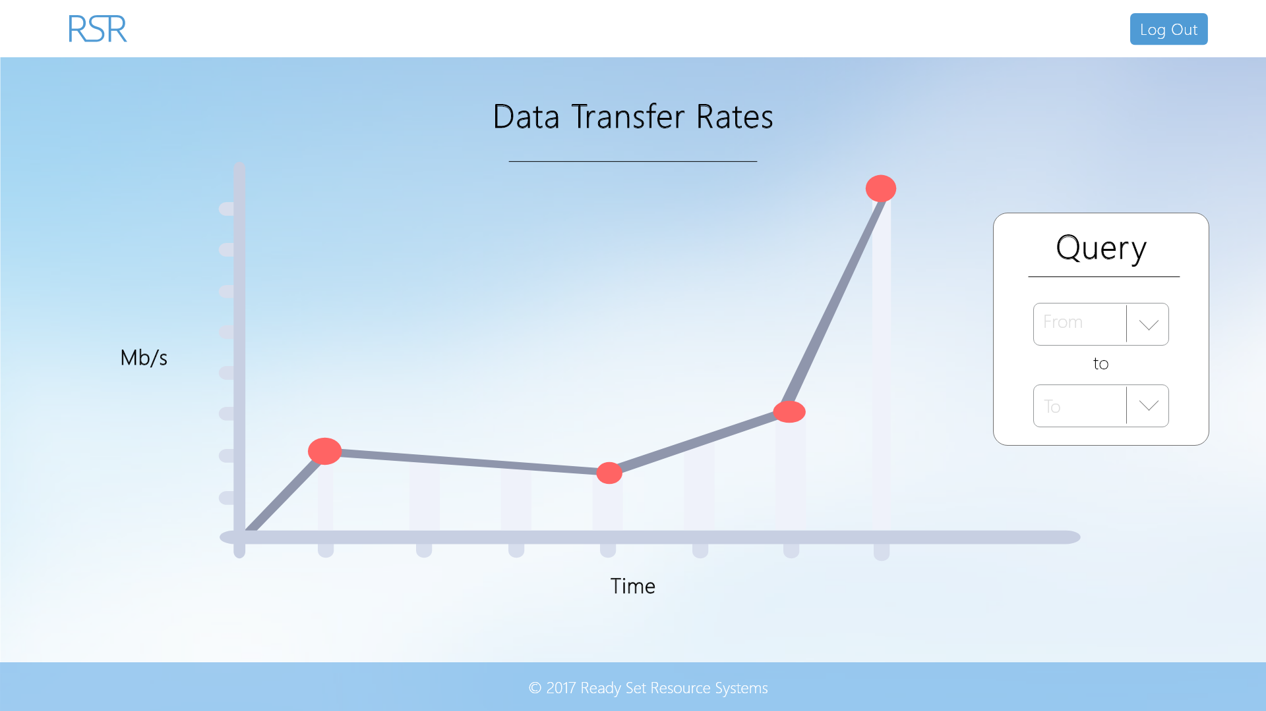

Input Permissible: - Date From

- Date To

Error Messages: - ‘Cannot select a date before start date’

# 13.4 - Traffic Analytics

I have decided that for the time being we will not be implementing traffic analytics as there are many other features and functionality that need to be implemented and the team wish to meet deadlines. This may be re-visited in the future for implementation.

# 13.5 - UID /dev/ Work Log

| Entry | Description | Person | Date | Mins Spent |
| --- | --- | --- | --- | --- |
| 1 | Formatted the document | Aidan Marshall | 19/3/18 | 3 |
| 2 | Designed the website | Aidan Marshall | 7/10/17 | 64 |
| 3 | Added screenshots and page details | Aidan Marshall | 7/10/17 | 27 |
| 94 | | | | |